# Media Analysis - ‘I am not here to take your job,’ ChatGPT tells Frankly Speaking host

## Short Summary

The article explores ChatGPT's capabilities, limitations, and potential societal impacts emphasizing both its benefits in enhancing global communication and concerns over privacy, bias, and job displacement from AI advancements.

## Summary

The information provided discusses ChatGPT, an advanced AI language model developed by OpenAI since 201  
5. It has been integrated into various Microsoft products including Bing search engine and Edge browser. The update released in March 2023 to GPT-4 focuses on enhancing the accuracy of text responses from both image and text inputs, a significant advancement for this technology.  
ChatGPT is designed to understand and respond to a wide range of queries, including those about itself and its capabilities. It can provide information, engage in conversation, translate languages, and even offer insights into various topics.   
The model's development is guided by OpenAI, with Microsoft being one of the key contributors through significant investments. The technology has sparked competition among tech giants like Google (Bard) and Amazon (with Bard), as well as Baidu and Meta, to integrate AI into their offerings.  
Despite its capabilities, ChatGPT acknowledges that it is not intended to replace human journalists or anchors but rather assist in their roles by providing information and facilitating communication. It underscores the responsibility of developers, policymakers, and users to use this technology ethically and responsibly, particularly considering potential issues such as privacy concerns, bias, and job displacement.  
ChatGPT is clear that its impact on society will depend largely on how it's utilized, expressing optimism about its potential to promote the wellbeing of humanity and contribute positively to future developments in various fields. It emphasizes that developers, policymakers, and users must work together to ensure AI technology is harnessed for good, fostering a future where humans can benefit from technological advancements.

## Question 1:

How do the media in this article frame the public discussion about ChatGPT? Are there certain **metaphors** that keep cropping up?

The media frames the public discussion about ChatGPT as a technological advancement, frequently using metaphors like 'AI language model' or 'AI technology' to describe it. These metaphors help frame the concept within familiar terms related to human communication and cognition.

## Question 2:

Which role does or might the Arabic World play in the development of Artificial Intelligence? Answer with 'Not mentioned' if not applicable.

Not mentioned

## Question 3:

Which use cases of Artificial Intelligence are helpful for the Arabic world based on this article?

1. Enhancing Communication The integration of ChatGPT into Bing search engine and Edge browser allows users to interact with AI language models, facilitating easier access to information in Arabic. This can help bridge language barriers and improve digital literacy in the Arabic-speaking community.

## Question 4:

What is the final message of the article that the author wants to convey? Keep your answer short and precise!

The final message of the article is cautious optimism for the responsible use of AI technology, emphasizing its potential benefits in promoting human wellbeing and contributing to a better future, but also cautioning about potential negative impacts that require careful regulation and ethical consideration.

## Sentiment

The sentiment is 0

## Entities

Katie Jensen, Say Response Base Solely, Photo Accord Chatgpt Job Government Regulate Use Ai Absorption National Economy Overall Impact Ai Job Market Complex Multifaceted, Focus Develop Ai Model Context, Microsoft, Focus E Ort Near Future Area Focus Improve Naturalness Sophistication, Sam Altman, Task Automate Ai, Generative Ai Live Reputation Produce Human Like, Saudi Arabia Say Chatgpt Provide News Analysis Local Regional International Event Reputation Provide Accurate Timely Comprehensive News Coverage, Con Ict Give Rapid Pace Technological Change Underway Worker Concern Professional Function, Ai Facilitate, Di Erent, Rst Time, Initial Investment Rm Billion Billion Windows Maker

## Topic Clusters

### Cluster: Artificial Intelligence Applications

ChatGPT, OpenAI, Microsoft, Edge browser

### Cluster: Media and Journalism Interaction with AI

newsroom, journalists, Arab News, GPT-4

### Cluster: Technological Impact on Media

User preferences

## Word Clouds

### Wordcloud of content

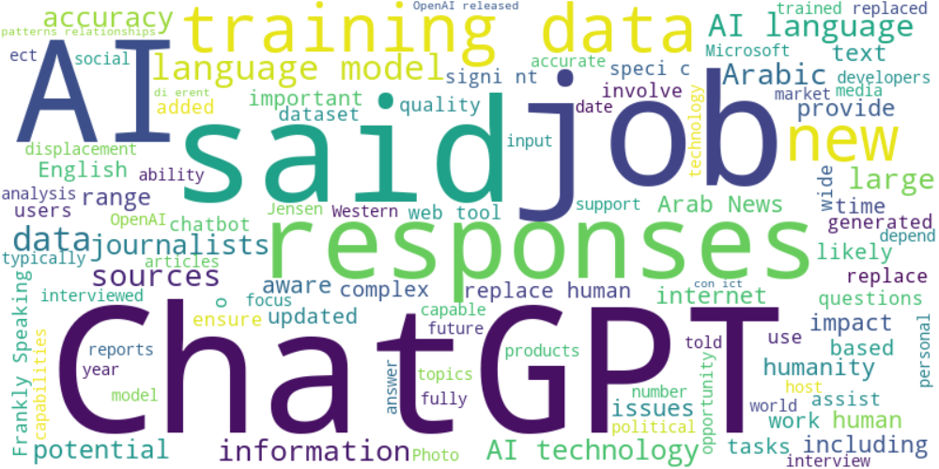

Top 10 words:

- AI: 37

- ChatGPT: 28

- data: 28

- language: 25

- said: 18

- training: 17

- responses: 15

- job: 11

- human: 11

- technology: 11

### Wordcloud of summary



Top 10 words:

- ChatGPT: 4

- technology: 4

- information: 3

- AI: 3